Diesel Watch DZ 4493 WATCH Men
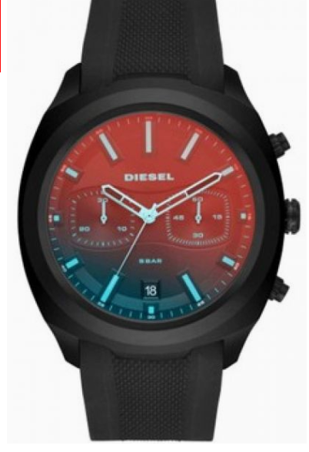
$250

.
This 48mm Tumbler watch features a black sunray dial with stick indexes, iridescent crystal lens, Unique, chronograph movement and black silicone strap. Available in men's sizes.
Case size :48mm x 56 mm
Case Thickness14 mm
Band Width26 mm
Water Resistant5 ATM
Warranty2 Year International
Origin: Imported
Closure: Strap Buckle

